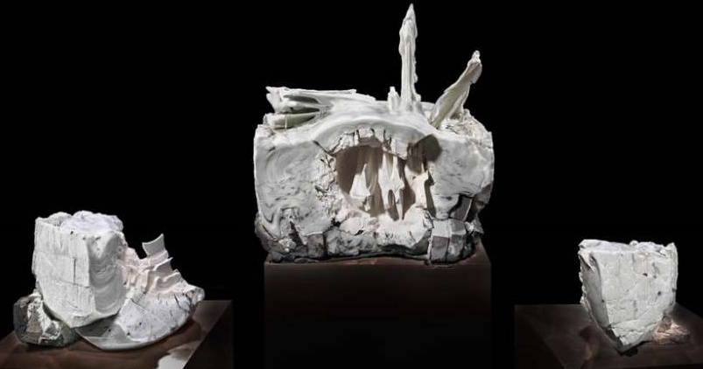
MFA Junior Artist Lesson Focus (August)
Theme: Wabi-sabi/Imperfection
Art: Zetsu #8, Nishida Jun (Gallery 269)

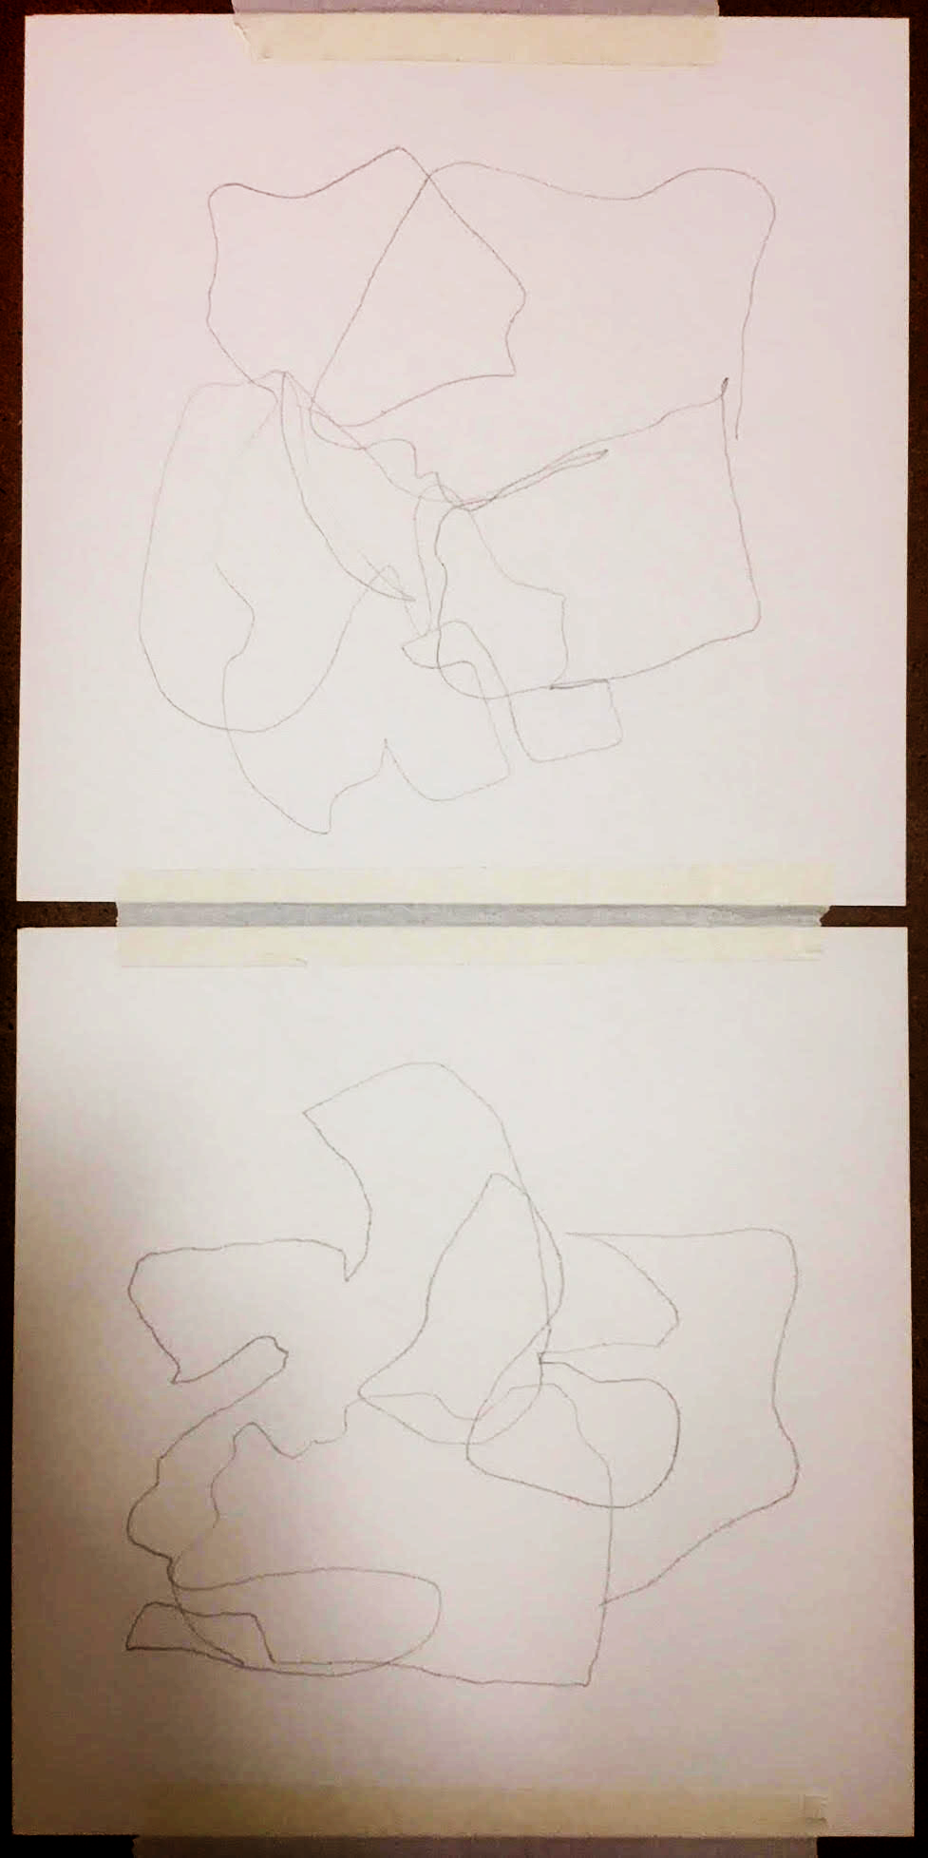
Objective: “Characteristics of the wabi-sabi aesthetic include asymmetry, roughness, simplicity, and appreciation of the ingenuous integrity of natural objects and processes”. Participants will explore this theme through the work of Nishida Jun, inspired by the way he saw his sculptures, as “living and changing.” Working with blind contour, ripping and folding paper participants will allow the work to come together through the process and very little planning on their own.
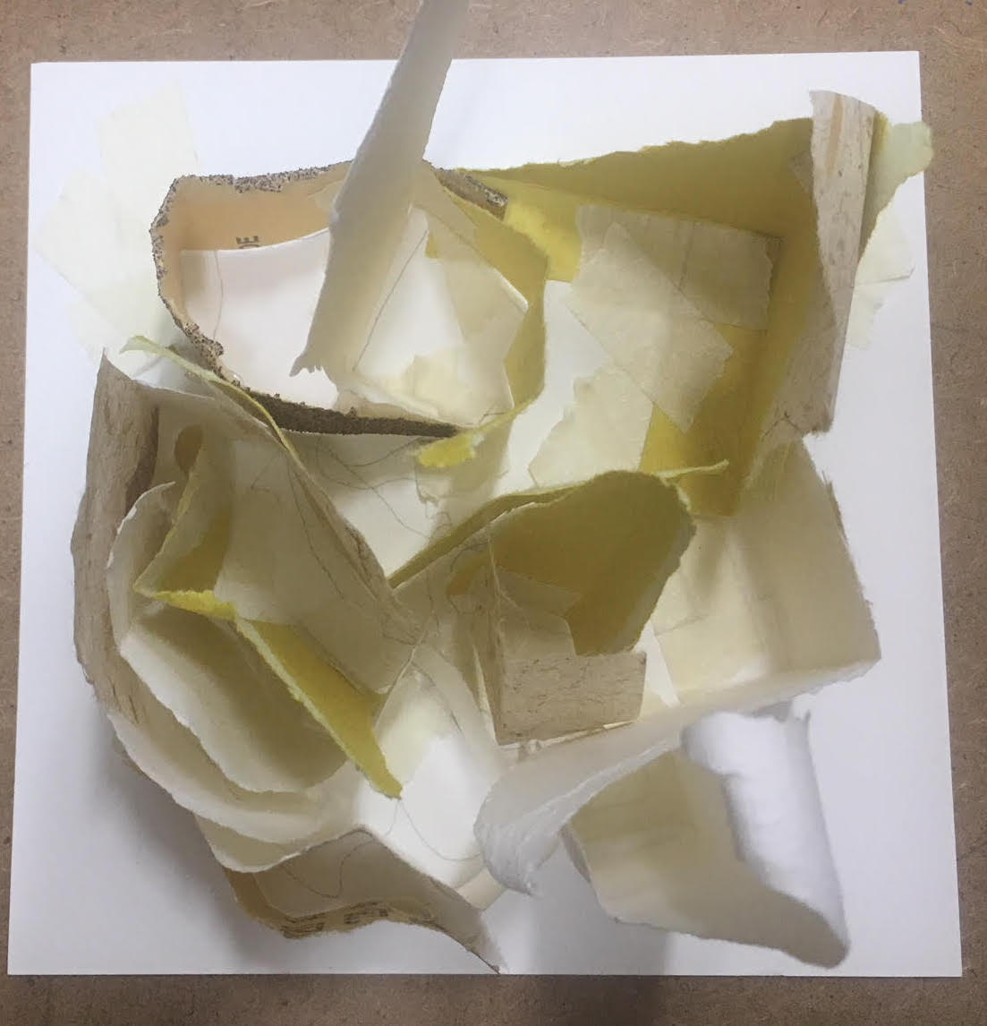

Looking questions:
Do you think this sculpture was designed before created ?
How do you think this work was made?
Does this sculpture remind you of anything you have seen before?

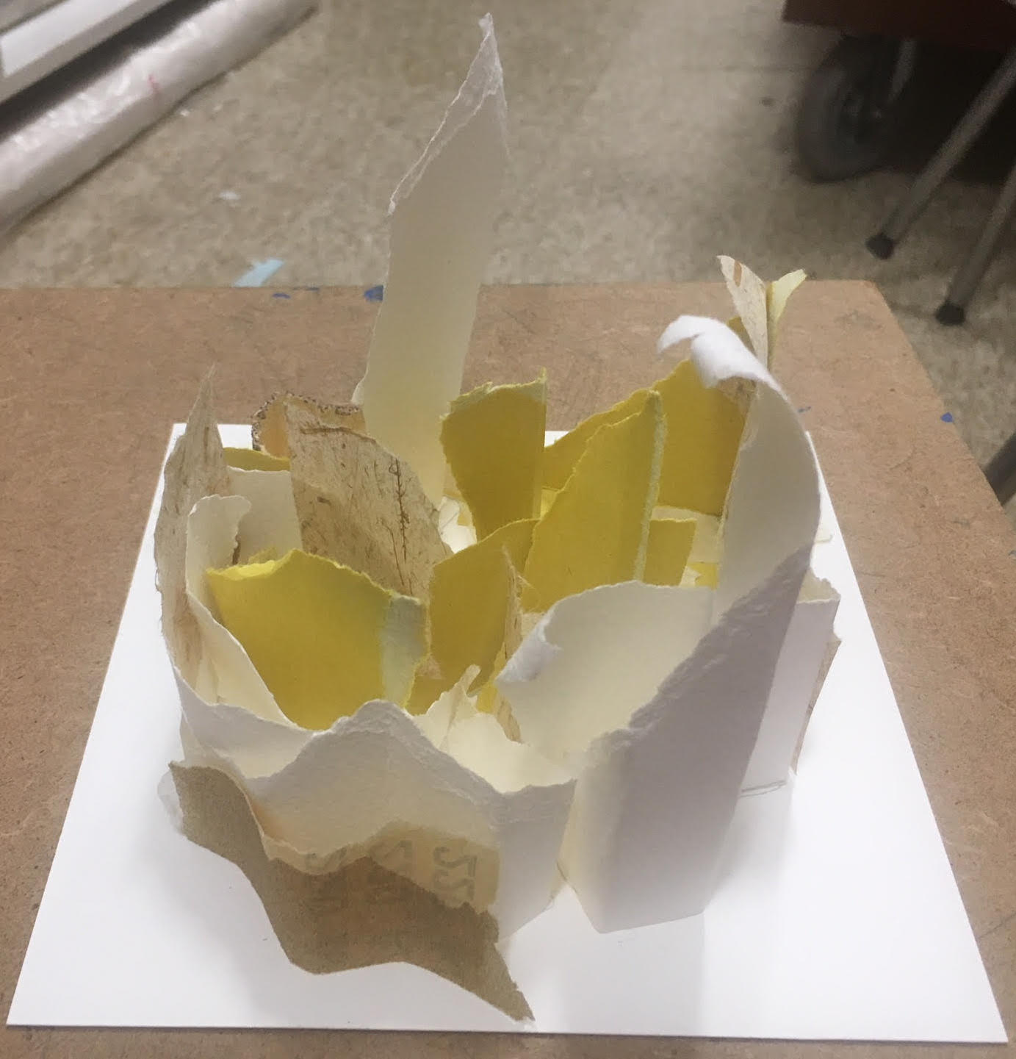
Engagement activity: Participants will begin with a blind contour drawings. Participants are encouraged to choose one of the 3 sculptures in the series to work from. Participants can draw the contour of the sculpture without looking at the paper, making the footprint of the sculpture.

Art Activity: Participants will then use ripped paper to fold and follow the contour lines of their drawing, starting at the center and building out. Using watercolor paper along with a mix of papers ripped to make rough edges mimicking the work of Zetsu #8.

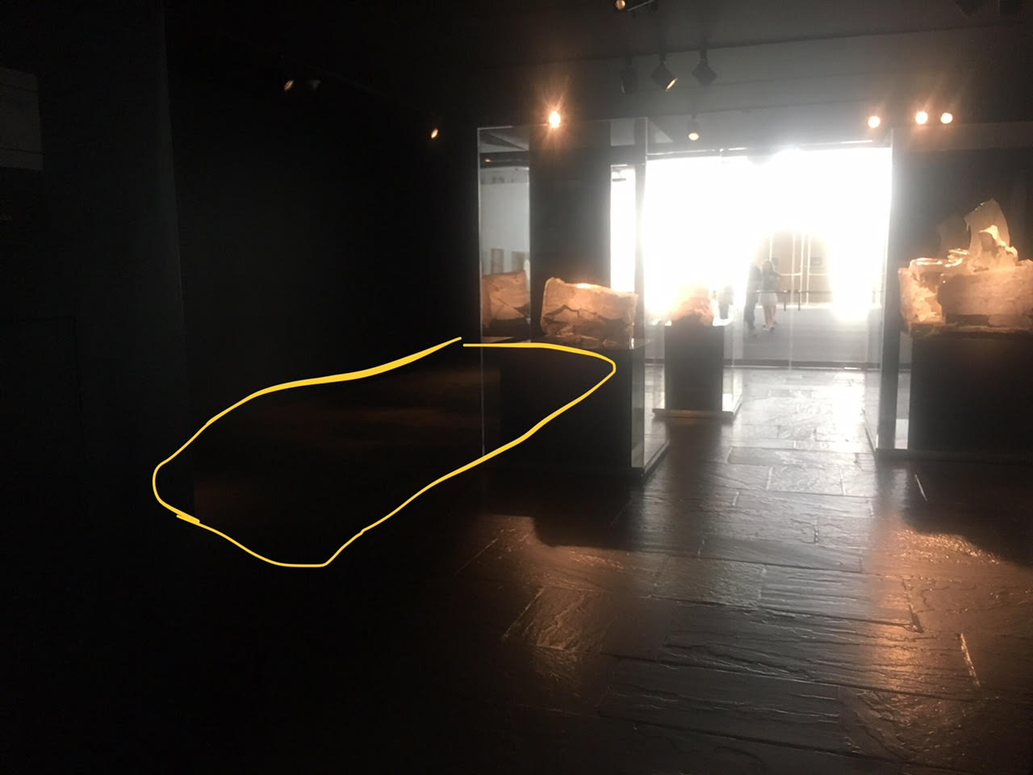
Materials:
Watercolor paper
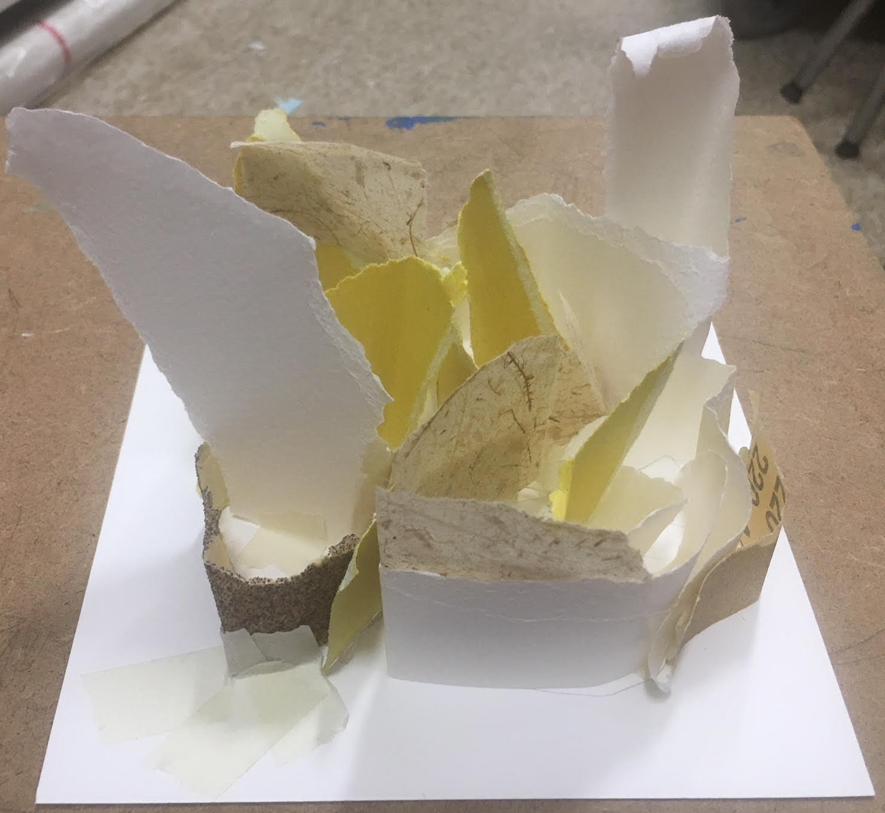
Sand Paper
Japanese paper
Glue dots
Masking tape (assorted colors and white)
Drawing pencils
Drawing boards
← Mat location in Gallery 269

