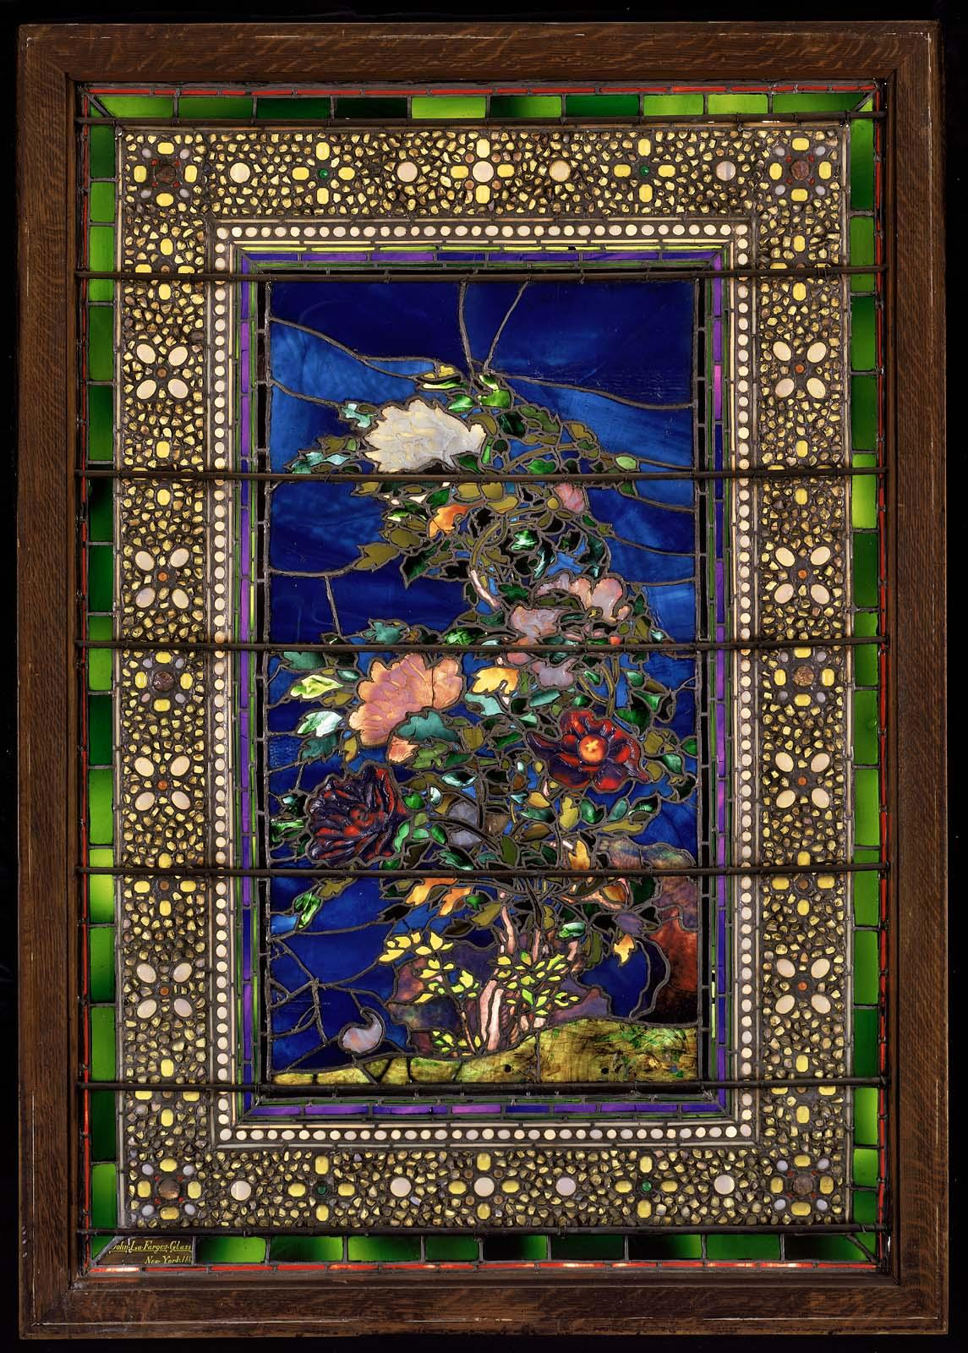
MFA Junior Artist Lesson Focus (May)
Light and Shadow
Art: Tiffany and La Farge Stained Windows (Gallery 224)

Objective: participants will explore shadow and light through translucent papers and films. Participants can see how a color or material can change do to the lighting they are in. In gallery 228 participants can examine the many art works on display show off many forms of light and shadow in many forms of mediums.

Looking questions:
How can a color change in light?
How can color change in shadow?
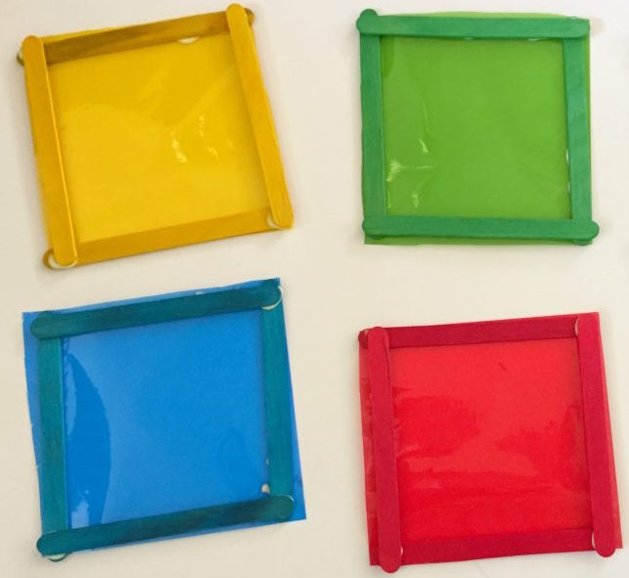
Engagement activity: Using frames filled with colored cellophane Participants can walk through the galleries in the American wing and see how light and show dow change in different colors and hues.

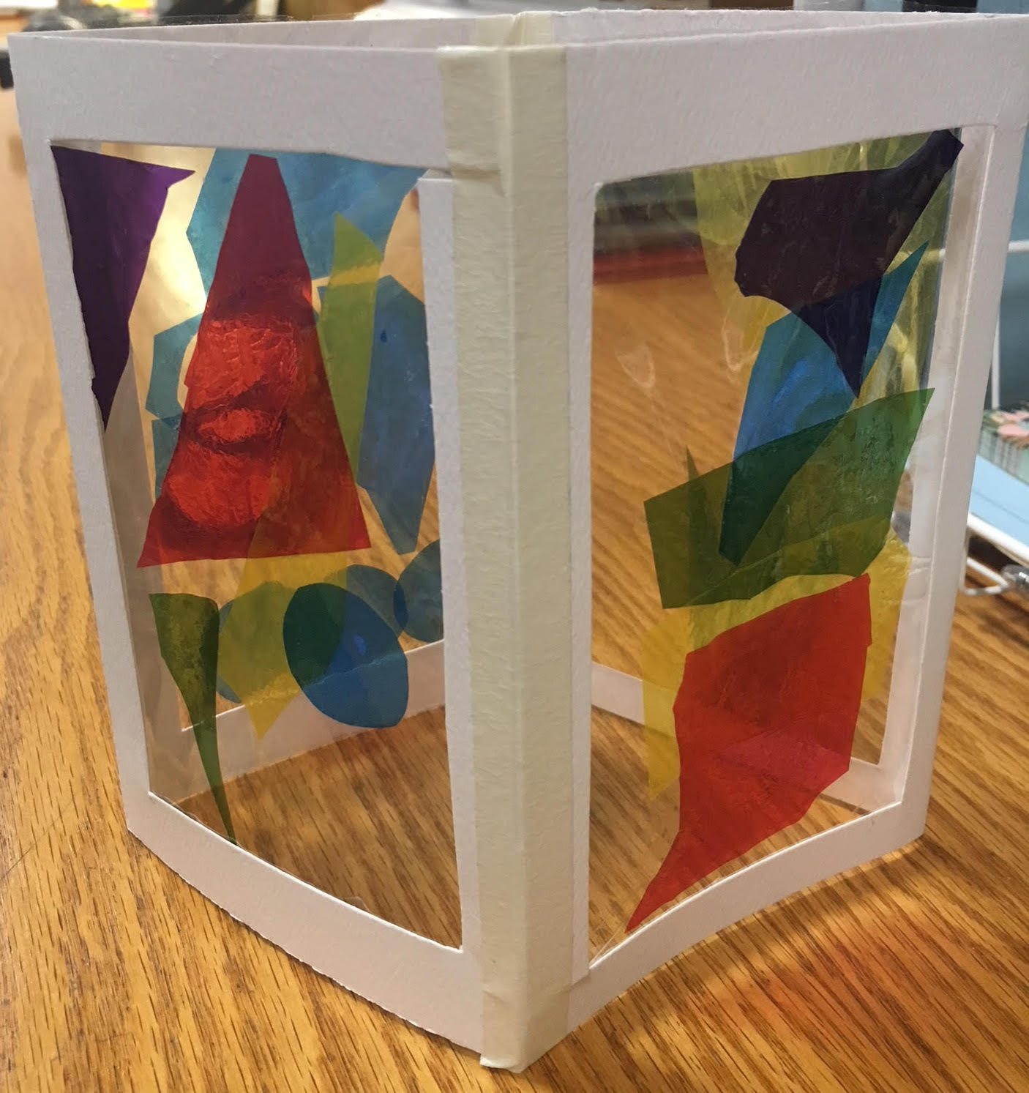
Art Activity: Participants will be given two double paper frames that will be filled with a clear cellophane. Participants will fill up their clear cellophane picture plane with colorful cellophane, Japanese paper, and tissue paper. Using layers to explore light and shadow participants will be encouraged to pause and see their work in different lights, holding the work up to the light or the window or blocking it from the light participants will think of how their work functions in different lights. When frames are filled they will construct their rectangular 3 dimensional box by taping both double frames together.

Materials:
Railroad board
Cellophane (clear)
Cellophane (assorted colors)
“Scrap paper” japanese paper
Tissue paper
Colorful tape
Glue sticks
Scissors

